CSAI 301 - Project Phase 2
Connect 4 Game
Ahmed Wael 202201415

Game Description: Connect Four

Game Overview
Connect Four is a classic two-player deterministic game played on a vertical 6×7 grid. Players alternate dropping colored discs into columns, with gravity pulling each disc to the lowest available position. The objective is to form a horizontal, vertical, or diagonal line of four consecutive discs before the opponent does.
Why Connect Four for Adversarial Search?
- Deterministic: No randomness; perfect information available to both players
- Two-player zero-sum: One player's gain is the other's loss
- Finite state space: Game always terminates within 42 moves
- Strategic complexity: Requires lookahead planning and threat analysis
- Computational tractability: Suitable for depth-limited search with pruning

State Representation
Board Structure:
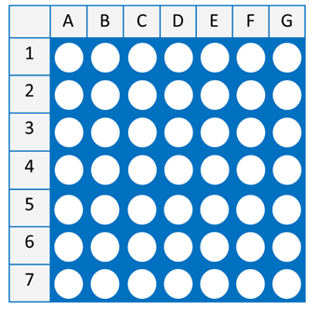
Implementation:
- Data Structure: 6×7 NumPy array
- Cell Values:
  - 0 = Empty cell
  - 1 = Player 1 (Maximizing player/AI)
  - 2 = Player 2 (Minimizing player/Opponent)

Initial State
The game begins with:
- An empty 6×7 board (all cells = 0)
- Player 1 designated to move first
- No pieces on the board
- Empty move history

Actions and Moves
Valid Actions: At any states, the set of legal actions consists of all columns that are not filled
Properties:
- Minimum actions: 0 (board full - terminal state)
- Maximum actions: 7 (empty board)
Move Execution: When a player selects column c:
- Find lowest empty row in column c
- Place player's disc at position (row, c)
- Update game state
- Switch player

End game States and Utility
End game Conditions:
1. Win Condition: Four consecutive discs of the same player in any direction:
- Horizontal, Vertical, Diagonal
2. Draw Condition:
- Board full and No player has achieved win condition
3. Loss Condition:
- Opponent achieves four-in-a-row

Game Tree Complexity
Branching Factor Analysis:
- Initial state: b = 7 (all columns available)
- Average state: b ≈ 4-5 (some columns filled)
- Late game: b ≈ 2-3 (most columns near full)
- Effective branching factor: b̄ ≈ 4
Depth Analysis:
- Maximum depth: d = 42 (all cells filled)
- Average game length: d̄ ≈ 35-40 moves
Why Appropriate for Minimax & Alpha-Beta:
- Finite horizon: Game always terminates
- Perfect information: Both players see entire board
- Zero-sum property: Enables minimax principle
- Reasonable branching: b ≈ 4 is manageable with pruning
- Evaluation feasible: Heuristics can approximate position strength

Minimax Algorithm

Description
Minimax is a recursive algorithm that explores the game tree to find the optimal move for the current player. It operates on the principle that:
- MAX player (Player 1) tries to maximize the evaluation score
- MIN player (Player 2) tries to minimize the evaluation score
Core Concept: MAX assumes MIN will play optimally, and vice versa. The algorithm recursively evaluates all possible move sequences up to a depth limit, then selects the move leading to the best guaranteed outcome.

Implementation Details
Key Features:
- Depth Limiting: Search stops at predetermined depth
- Terminal Detection: Checks for win/loss/draw conditions
- Move Ordering: Prioritizes center columns for better efficiency
- Performance Tracking: Counts nodes explored and time taken

Advantages and Limitations
Advantages:
- ✓ Guaranteed to find optimal move
- ✓ Simple to understand and implement
- ✓ Always correct with sufficient depth
Limitations:
- ✗ Explores all nodes (no pruning)
- ✗ Exponential time complexity: O(b^d)
- ✗ Slow for deeper searches
- ✗ Examines obviously bad moves

Alpha-Beta Pruning Algorithm

]escription
Alpha-Beta Pruning is an optimization of Minimax that eliminates branches in the game tree that cannot possibly influence the final decision. It maintains two values:
- Alpha (α): Best value MAX can guarantee so far
- Beta (β): Best value MIN can guarantee so far
Key Insight: If MIN finds a move worse (for MAX) than what MAX can already achieve elsewhere, there's no need to explore further in that branch.

Pruning Conditions
Beta Cutoff (in MAX node):
if β ≤ α:
prune remaining branches
(MIN already has better option elsewhere)
Alpha Cutoff (in MIN node):
if β ≤ α:
prune remaining branches
(MAX already has better option elsewhere)

Implementation Features
Optimizations:
- Move Ordering: Center columns examined first (better pruning)
- Pruning Counter: Tracks number of cutoffs
- Metrics Tracking: Performance comparison with Minimax
- Same Interface: Drop-in replacement for Minimax

3.5 Complexity Analysis
Time Complexity:
- Best case: O(b^(d/2)) - perfect move ordering
- Average case: O(b^(3d/4)) - random ordering
- Worst case: O(b^d) - worst possible ordering
Space Complexity:
- O(d) - recursive call stack
Practical Impact:
- Depth 6 Minimax: ~4⁶ = 4,096 nodes
- Depth 6 Alpha-Beta: ~4³ = 64 nodes (best case)
- Effective doubling of searchable depth

Evaluation Function

Purpose
Since searching to terminal states is infeasible (depth 40+), we need a heuristic evaluation function to estimate the "goodness" of non-terminal positions.
Design Goals:
- Fast computation (called millions of times)
- Accurate position assessment
- Captures strategic features
- Differentiates winning vs. losing positions

Evaluation Components
1. Window Counting
A "window" is any sequence of 4 consecutive positions (horizontal, vertical, or diagonal).
Scoring:
Four-in-a-row (win): +1000
Three-with-one-empty: +10
Two-with-two-empty: +2
Blocked (mixed pieces): 0
Center Column Control
The center column (column 3) is strategically valuable as it participates in more potential winning lines.
Scoring:
Each piece in center column: +3 points
Rationale:
- Center creates more four-in-a-row possibilities
- Controls board geography
- Empirically strong in Connect Four strategy
2. Opponent Evaluation
The evaluation considers both players:
Score = (Player_Features) - (Opponent_Features)
This creates a relative advantage metric rather than absolute position strength.

Why This Function Works
1. Captures Immediate Threats:
- Three-in-a-row scores +10, making it valuable
- AI will prioritize creating threats or blocking opponent threats
2. Strategic Positioning:
- Two-in-a-row gets +2
- Center control bonus promotes strong positions
3. Balanced Evaluation:
- Considers both offensive and defensive features
- Relative scoring prevents bias
4. Computational Efficiency:
- Linear scan through board: O(rows × cols)
- No complex pattern matching

Limitations and Future Improvements
Current Limitations:
- Doesn't detect complex forced-win sequences beyond depth
- Equal weight to all three-in-a-row (some are stronger)
- No consideration of "traps" (multi-threat positions)
Potential Improvements:
- Threat detection: Immediate win/block recognition
- Pattern library: Known strong/weak configurations
- Dynamic weights: Adjust based on game phase

Performance Comparison
============================================
Test 1: Early game (few moves)
============================================================
RESULTS
============================================================

Criterion Minimax Alpha-Beta
------------------------------------------------------------
Best Move Column 3 Column 3
Time Taken (s) 16.9490 0.5710
Nodes Explored 19608 778
Max Depth Reached 5 5
Best Score 12 12
Branches Pruned N/A 131
============================================
EFFICIENCY ANALYSIS
============================================

Time Improvement: 96.63% faster
Nodes Reduction: 96.03% fewer nodes
Pruning Efficiency: 131 branches pruned
Same Best Move: True
============================================

Test 2: Mid game
============================================================
RESULTS
============================================================

Criterion Minimax Alpha-Beta
------------------------------------------------------------
Best Move Column 5 Column 5
Time Taken (s) 14.1387 4.4714
Nodes Explored 15699 5374
Max Depth Reached 5 5
Best Score -8 -8
Branches Pruned N/A 662
============================================
EFFICIENCY ANALYSIS
============================================

Time Improvement: 68.37% faster
Nodes Reduction: 65.77% fewer nodes
Pruning Efficiency: 662 branches pruned
Same Best Move: True
============================================
Test 3: Complex position
============================================================
RESULTS
============================================================

Criterion Minimax Alpha-Beta
------------------------------------------------------------
Best Move Column 2 Column 2
Time Taken (s) 112.5486 11.6636
Nodes Explored 130607 14210
Max Depth Reached 6 6
Best Score 2 2
Branches Pruned N/A 2458
============================================
EFFICIENCY ANALYSIS for Alpha-Beta
============================================
Time Improvement: 89.64% faster
Nodes Reduction: 89.12% fewer nodes
Pruning Efficiency: 2458 branches pruned
Same Best Move: True

Visual Results
Minimax vs Alpha-Beta
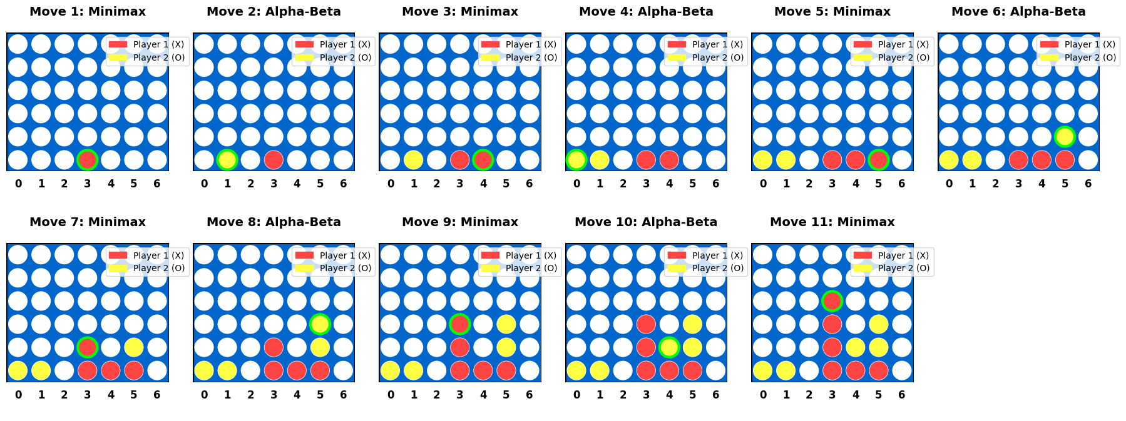
Performance Comparison Visualization
